Project Design Phase-II
Data Flow Diagram & User Stories

Date | 18 February 2026
Team ID | LTVIP2026TMIDS80016
Project Name | Flavour Fusion: AI- Driven recipe Blogging
Maximum Marks | 4 Marks

Data Flow Diagrams:
A Data Flow Diagram (DFD) is a traditional visual representation of the information flows within a system. A neat and clear DFD can depict the right amount of the system requirement graphically. It shows how data enters and leaves the system, what changes the information, and where data is stored.

Example: (Simplified)
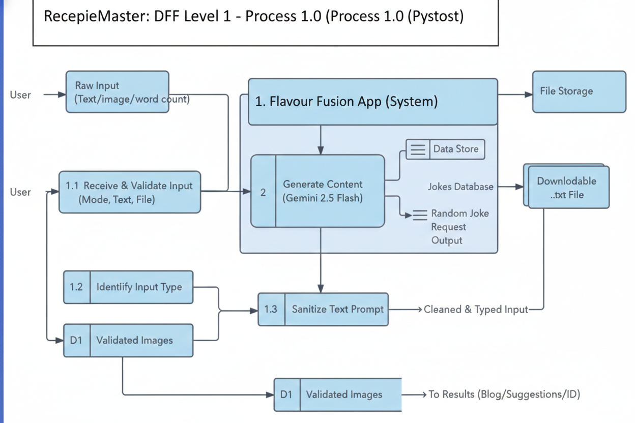

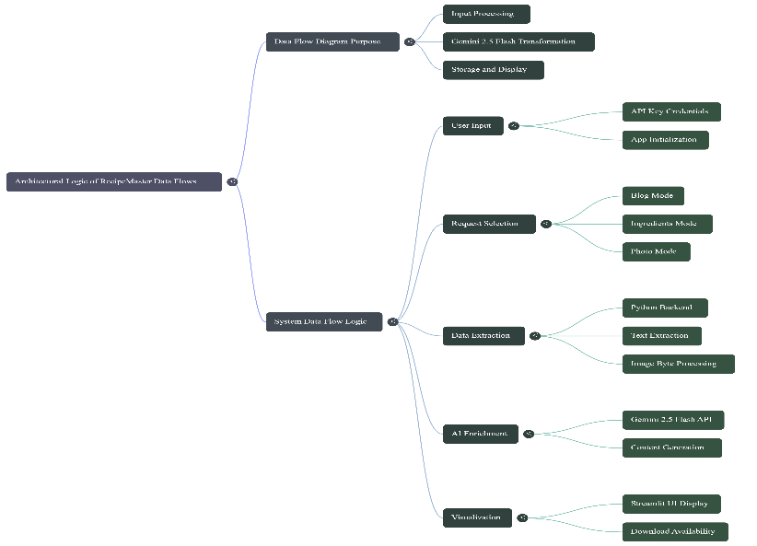

User Stories
Use the below template to list all the user stories for the product.
User Type | Functional Requirement (Epic) | User Story Number | User Story / Task | Acceptance criteria | Priority | Release
Customer (Web user) | Blog Generation | USN-1 | As a blogger, I want to input a dish name and word count so I can get a full blog post instantly. | A formatted blog with Title, Ingredients, and Steps appears. | High | Sprint-1
 |  | USN-2 | As a user, I will receive confirmation email once I have registered for the application | I can receive confirmation email & click confirm | High | Sprint-1
Customer (Web user) | Ingredient Suggestion | USN - 3 | As a cook, I want to list my ingredients so I can discover 3-5 new dish ideas. | The UI displays a list of specific, edible dish suggestions. | High | Sprint - 1
Content Creator | Multimodal ID | USN - 4 | As a creator, I want to upload a food photo so the AI can identify the dish and provide its recipe. | The AI identifies the dish in the image and generates a blog. | Medium | Sprint- 2
All Users | Engagement (UX) | USN - 5 | As a user, I want to see a joke while the AI is thinking so that the wait time feels shorter. | A random programmer joke is displayed during the "Loading" state | Medium | Sprint -2
All Users | Data Export | USN - 6 | As a user, I want to download the generated recipe as a text file for offline use | A .txt file containing the recipe is saved to the local device. | Medium | Sprint- 1
Administrator | Security | USN - 7 | As an admin, I want to manage API keys via environment variables to prevent unauthorized access. | The app loads only if a valid .env file with the API key is present | High | Sprint -1

